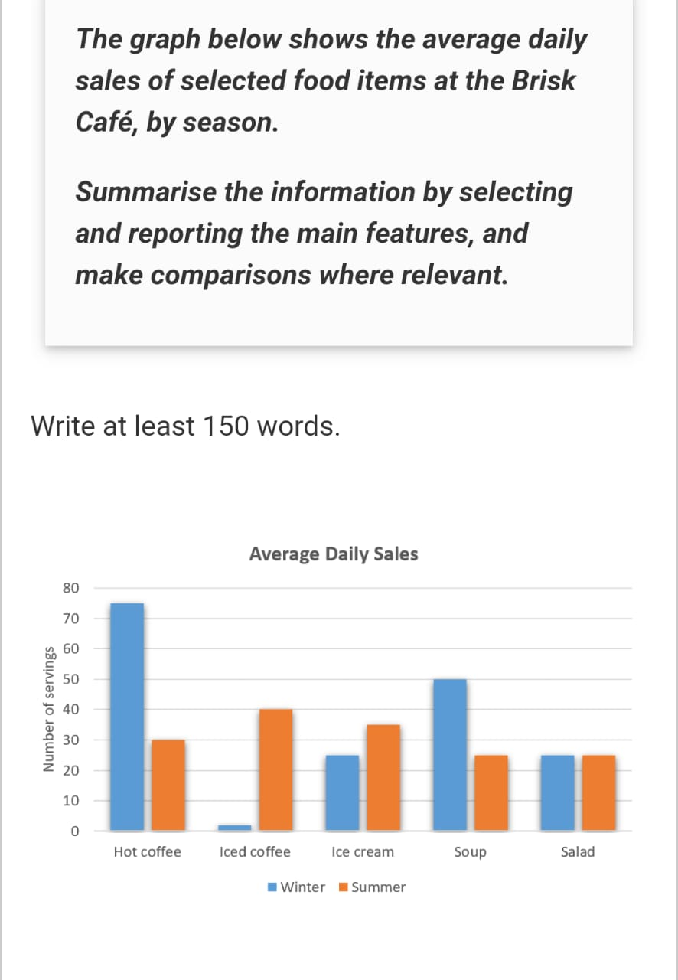
Muhammad Umar Farooq
Writing task 1

The graph illustrates the average number of daily servings of selected food items at the Brisk Café, during Winter and Summer.

Overall, Hot coffee and Soup were more popular in Winter, while Iced coffee and Ice cream saw higher sales in Summer. Salad remained constant in both seasons.

In detail, Hot coffee was the most consumed item in the Winter, reaching about 75 servings per day, while in Summer it dropped to about 30.
Soup was the second most popular in Winter with about 50 servings, but sales decline to around 28 in Summer.
Salad remained steady across both seasons at around 25 servings daily, which depicted it is not the seasonal bound food item. Iced coffee, however, showed a sharp seasonal contrast, with nearly 40 servings in summer and fewer than 5 in winter.
Ice cream also expressed a seasonal preference, with approximately 25 servings in winter and 35 in summer.

